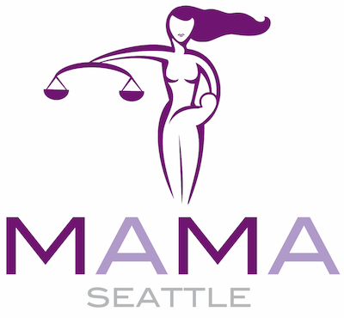

APPLICATION
MAMA Seattle/FDCC Ladder Down Program
Part I: Background and Contact Information
Name:
Preferred contact address:
Preferred Email:
Cell phone: Work phone:
Current Employer:
Title/Position: Year of Law School graduation: ______
Part II: Narrative Questions
The following information is sought so we can assemble a class of women attorneys with a variety of experiences, practice areas, and goals. The information you disclose will be reviewed only by the faculty and selection committee, will be kept in confidence, and will not disclosed to other class participants.

The questions below should be answered in no more than two single-spaced pages.

- Describe your practice:

- List representative clients and/or types of clients (e.g., insurance companies, privately held, midsized companies; national corporations, injured workers/employees, etc.).

- Describe your current business development activities.

- Describe your business development successes (this could include: significant clients, your book of business, expansion/management of existing firm clients, opportunities for pitching work, etc.).

- Describe the challenges you are currently facing in business development and any other aspects of your legal career.

- Describe what you hope to gain from participating in Ladder Down.

- Describe your professional goals for the next 3-5 years.

- Are you a member of MAMA Seattle? ____ Yes ____ No

- Are you a member of FDCC? ____ Yes ____ No

- Describe your participation in MAMA Seattle and/or FDCC.

Part III: Resume/CV and Short Bio:
Please submit (1) a current resume/CV along with your application. Upon acceptance, you will be asked to submit a single-page pdf biography with photo to be shared with Ladder Down class members.

Part IV: Financial Agreement
By signing below, I understand that the fee for the Ladder Down program is $1250. This fee will be invoiced upon notification of the acceptance of my application to the class and due within ten (10) days of your enrollment.
____ I agree to pay as stated above and will ensure payment within 10 days of my acceptance to the Ladder Down Class.
____ I intend to apply for a partial scholarship from MAMA Seattle and am attaching a letter describing my circumstances and the amount of scholarship I am requesting.
Dated: By: ___________________________
Please submit completed application, along with a copy of your current resume/CV to:
LadderDown@mamaseattle.org no later than November 14th.

MAMA Seattle may grant partial scholarships on a case-by-case basis to MAMA Seattle members who fall into one of the following categories: solo practitioner, attorney at a firm with fewer than 10 lawyers and tuition is not paid for by the law firm, government/public interest attorney, on-ramping mother attorney, attorney in career transition, and where financial circumstances otherwise warrant assistance. Please submit a scholarship request with letter of explanation along with your application.

